H.T No
Regulations:
A14

Sreenidhi Institute of Science and Technology
(An Autonomous Institution)
Code No: 4B616 Date: 09-July-2021(FN)

B.Tech III-Year II- Semester Pending External Examination, July-2021 (Supplementary)
Principle of Finite Element Method (ME)

Time: 3 Hours Max.Marks:70

Note: a) No additional answer sheets will be provided.
b) All sub-parts of a question must be answered at one place only, otherwise it will not be valued.
c) Missing data can be assumed suitably.

ANSWER ANY 5 OUT OF 8 QUESTIONS. EACH QUESTION CARRIES 14 MARKS.

Bloom's Cognitive Levels of Learning (BCLL)

Remember | L1 | Apply | L3 | Evaluate | L5
Understand | L2 | Analyze | L4 | Create | L6

 |  |  | BCLL | CO(s) | Marks
1. |  | Compute the stresses developed in AB, BC, and CD of the bar shown in Fig. Area of AB is 0.001 m² and length is 2 m. Area of BC is 0.002m² and length is 1 m. Area of CD is 0.001 m² and length is 1.5m. Modulus of elasticity is 200 GPa.  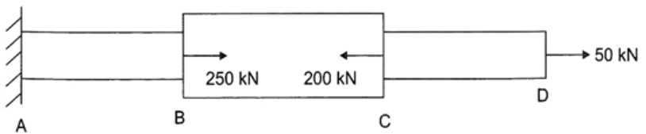 | L3 | CO1 | [14M]
2. |  | For the plane truss shown in Figure ,  determine the displacement components at nodes.  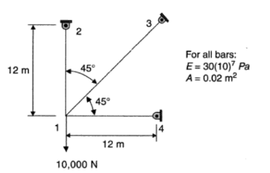 | L4 | CO2 | [14M]
3. |  | The coordinates of the nodes 1, 2 and 3 of a triangular element are (1, 1), (8, 4) and (2, 7) in mm. The displacements at the nodes are u₁ = 1 mm, u₂ = 3 mm, u₃ = -2 mm, v₁ = -4 mm , v₂ = 2 mm and v₃ = 5 mm. Obtain the strain-displacement relation matrix B and determine the strain matrix | L4 | CO3 | [14M]
4. |  | 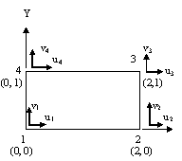  A rectangular element is shown in figure. Evaluate Jacobian matrix at ξ = 0, η = 0 and determine the strain displacement matrix | L4 | CO4 | [14M]
5. |  | A metallic fin, with thermal conductivity 360 W/m ºK, 0.1 cm thick and 10 cm long extends from a plane wall whose temperature is 235°C. Determine the temperature distribution along the fin if heat is transferred to ambient air at 20°C with heat transfer coefficient of 9 W /m² ⁰K. Take width of fin as 1 m. | L3 | CO5 | [14M]
6. |  | Determine the lowest eigen value and the corresponding mode shape for the beam shown in figure.  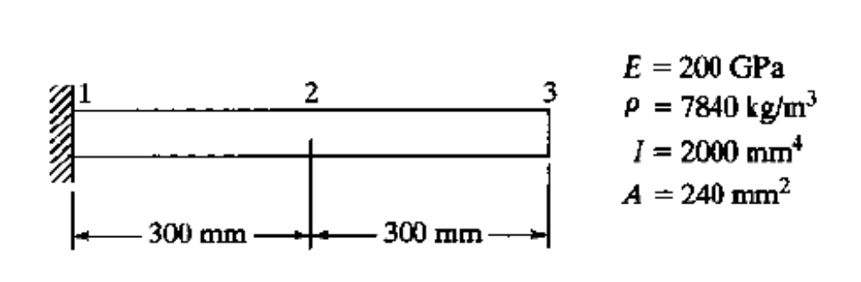 | L3 | CO6 | [14M]
7. | a) | Briefly describe the various weighted residual methods. | L2 | CO1 | [7M]
 | b) | Derive the stiffness matrix for the Constant strain triangular element | L3 | CO2 | [7M]
8. | a) | Write short notes on Jacobian matrix | L1 | CO4 | [7M]
 | b) | Derive the element mass matrix for a one dimensional bar element using Lumped parameter model | L3 | CO5 | [7M]

-- 00 -- 00 –

